March Madness Analytics — Final Project Report

Univariate Statistics
This section summarises the pre-cleaning exploration of every column in the assembled matchups dataset (924 rows × 67 columns). The analysis identifies data-quality issues that inform the cleaning decisions applied before modeling.

Column Classification
Type | Count | Representative Columns
Continuous numeric | 61 | adj_em_diff, barthag_diff, wab_diff, seed_diff, score_margin, …
Boolean (0/1) | 3 | game_result, is_big_gap, is_late_round
Categorical / ID | 6 | season, teamA_id, teamB_id (+ 3 derived)

Summary Statistics Table — Continuous Numeric Features
All 61 continuous columns have 924 complete observations except the three tempo columns (78.6% missing). The table below shows a representative subset; the full 61-row table is available in the notebook (§1.10b).
Column | Mean | Median | Std | Min | Max | Skewness | Kurtosis | Missing %
teamA_seed | 4.197 | 3.000 | 3.385 | 1.000 | 16.000 | +1.56 | 2.59 | 0.0%
teamB_seed | 10.197 | 11.000 | 3.896 | 1.000 | 16.000 | −0.39 | −0.67 | 0.0%
seed_diff | −6.000 | −5.000 | 4.335 | −15.000 | 0.000 | −0.44 | −0.77 | 0.0%
score_margin | 6.956 | 7.000 | 13.048 | −34.000 | 47.000 | +0.05 | 0.17 | 0.0%
total_points | 139.486 | 139.000 | 18.664 | 90.000 | 202.000 | +0.22 | −0.03 | 0.0%
adj_em_diff | 9.027 | 7.249 | 9.460 | −12.650 | 46.030 | +0.99 | 1.03 | 0.0%
barthag_diff | 0.121 | 0.067 | 0.155 | −0.217 | 0.690 | +1.52 | 1.96 | 0.0%
wab_diff | 5.095 | 4.221 | 4.816 | −8.650 | 25.304 | +1.07 | 1.36 | 0.0%
a_barthag | 0.902 | 0.925 | 0.099 | 0.253 | 0.984 | −4.15 | 20.08 | 0.0%
a_adj_t | 67.592 | 67.757 | 2.764 | 61.323 | 75.064 | −0.03 | −0.05 | 78.6%
b_adj_t | 67.298 | 67.455 | 2.564 | 59.136 | 75.103 | −0.04 | +1.20 | 78.6%
adj_t_diff | 0.294 | 0.295 | 3.796 | −9.100 | 13.181 | +0.16 | +0.11 | 78.6%
a_coach_tourn_wins | 18.424 | 10.000 | 21.380 | 0.000 | 97.000 | +1.60 | 2.17 | 0.0%
a_coach_final_fours | 0.948 | 0.000 | 1.833 | 0.000 | 9.000 | +2.67 | 7.71 | 0.0%
b_coach_tourn_wins | 6.978 | 1.000 | 12.903 | 0.000 | 91.000 | +2.84 | 8.89 | 0.0%
b_coach_final_fours | 0.249 | 0.000 | 0.825 | 0.000 | 9.000 | +5.18 | 38.61 | 0.0%
seed_disagreement | 0.000 | −0.219 | 5.605 | −19.919 | 21.179 | +0.21 | 0.39 | 0.0%
sos_diff | 0.038 | 0.032 | 0.061 | −0.118 | 0.232 | +0.34 | −0.30 | 0.0%
ast_rate_diff | 0.010 | 0.011 | 0.073 | −0.185 | 0.238 | +0.04 | −0.10 | 0.0%

Summary Statistics Table — Boolean Features
Column | Count | Missing | Mean | % Positive
game_result | 924 | 0 | 0.725 | 72.5%
is_big_gap | 924 | 0 | 0.374 | 37.4%
is_late_round | 924 | 0 | 0.227 | 22.7%

Key Univariate Visualizations
Rather than reproducing every histogram from the 61 continuous columns, the six plots below highlight the patterns and issues most relevant to modeling:
1. teamA_seed histogram
Right-skewed distribution (skew = +1.56). Lower seeds (1–4) dominate because Team A is always the lower (favored) seed by construction. This is a structural property of bracket assembly, not a recording error.
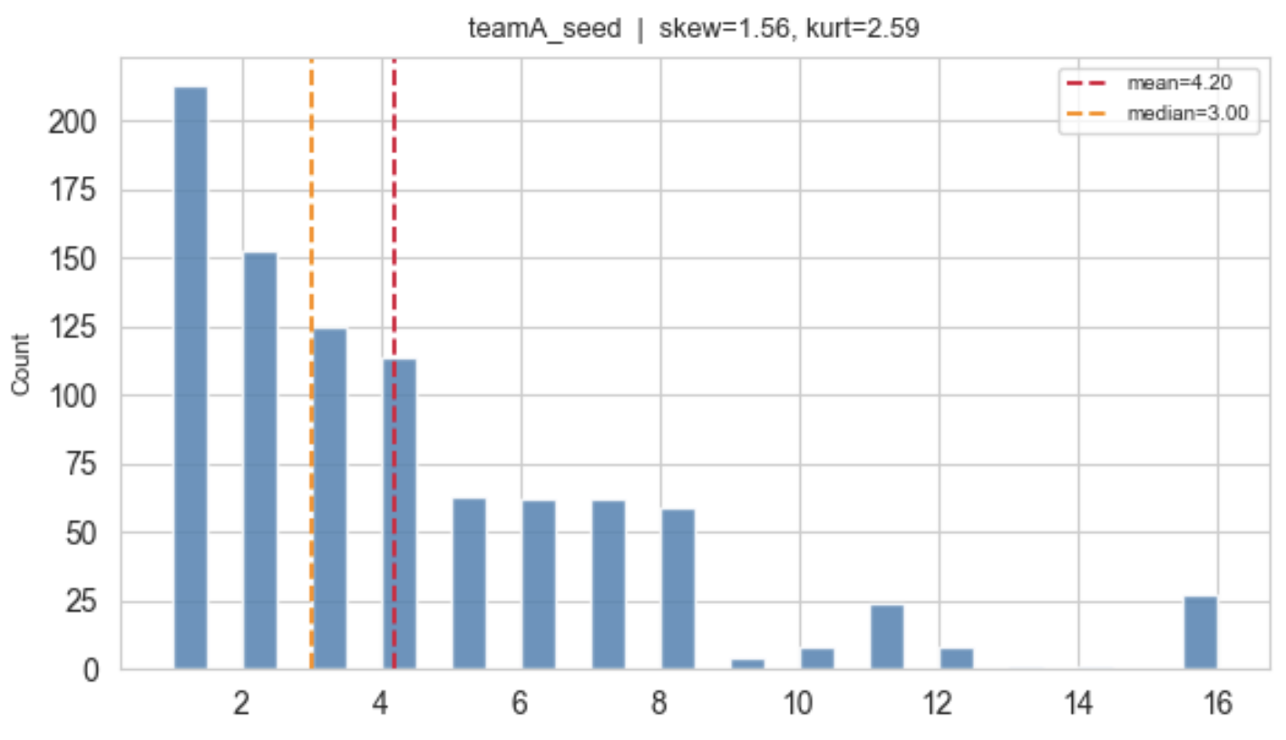
2. a_barthag boxplot
Severely left-skewed (skew = −4.15, kurtosis = 20.08) with 27 extreme outliers beyond the 3×IQR fence. Elite teams cluster near 1.0, creating a long lower tail from the few weak tournament qualifiers. These are legitimate observations.
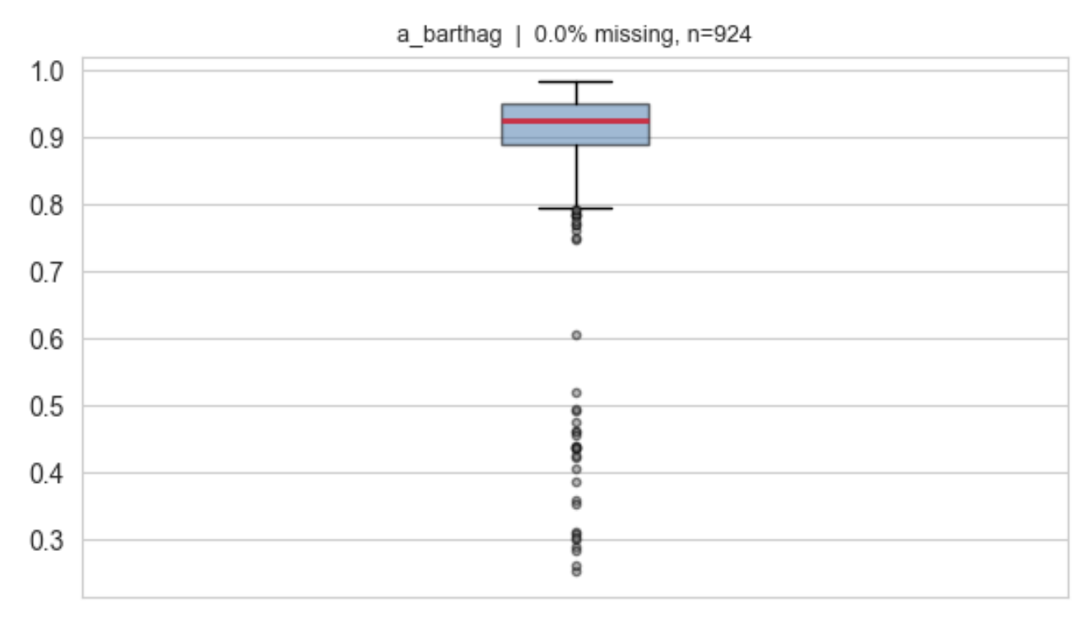
3. adj_t_diff histogram (missing-value annotation)
78.6% of values are missing — the dominant data-quality issue in the dataset. Barttorvik tempo data is absent from pre-2019 CSV files. The 198 non-missing rows are roughly normally distributed around zero, but the near-total absence renders this column unusable for modeling.
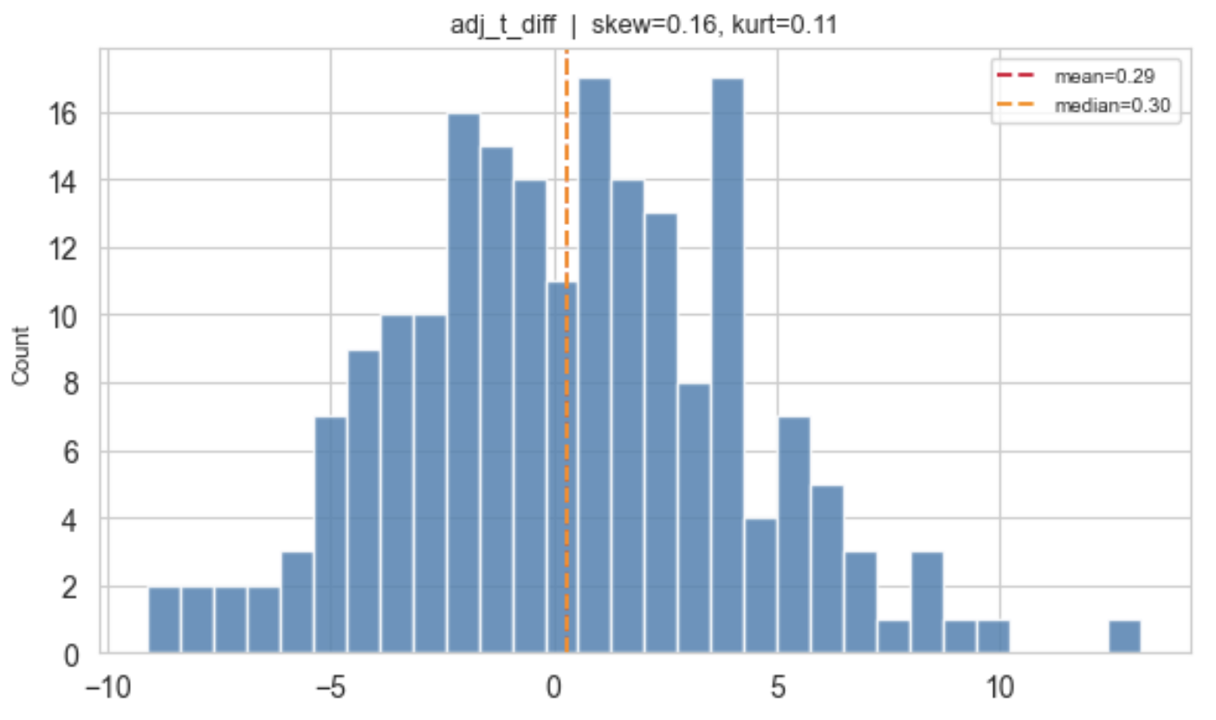
4. score_margin histogram
Near-perfectly symmetric (skew = +0.05), approximating a normal distribution centred at +6.96 (Team A wins by ~7 points on average). No transformation required. This is the primary regression target.
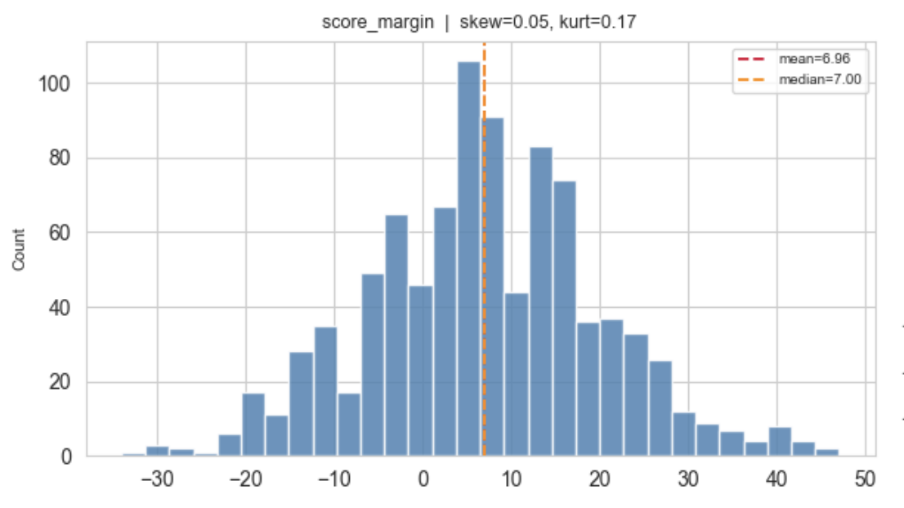
5. b_coach_final_fours boxplot
Extreme right skew (skew = +5.18, kurtosis = 38.61) with 113 outliers. The distribution is zero-inflated: most Team B coaches have zero Final Four appearances, while a small cohort (e.g., Coach K, Roy Williams) have 5–9. A meaningful signal, but requires attention in linear models.
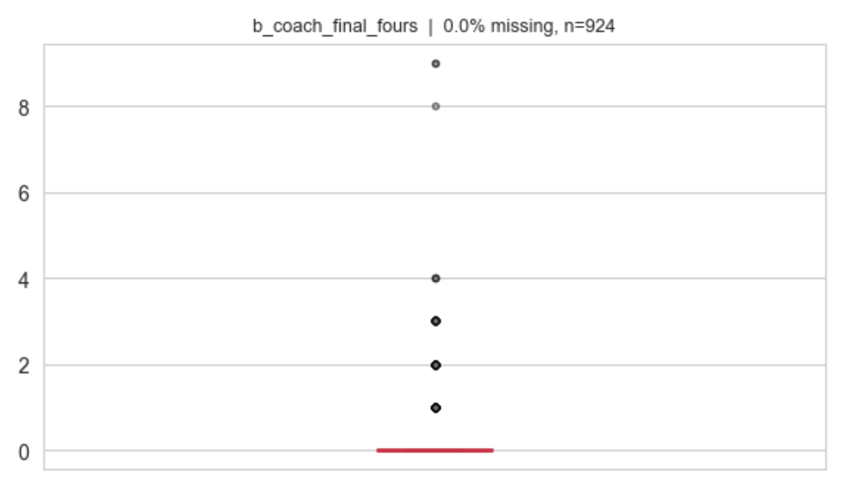
6. game_result count plot
72.5% of games are won by Team A (the lower seed), confirming the bracket seeding structure and flagging a modest class imbalance for binary classification tasks. Stratified cross-validation will be used during modeling.
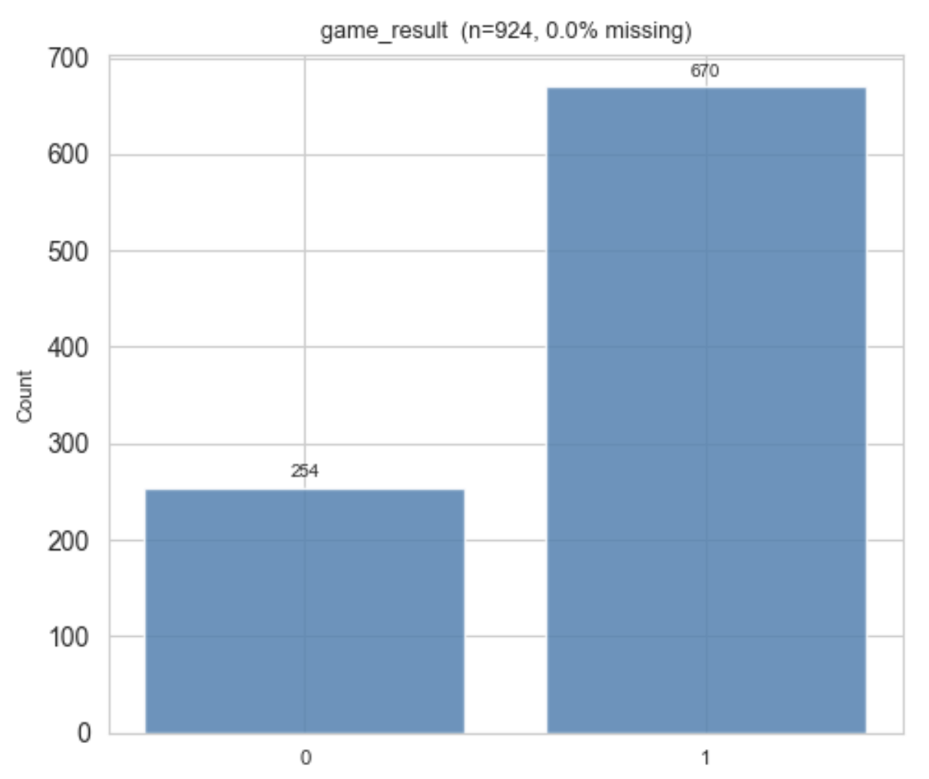

Data Quality Issues and Phase 2 Remediation Plan
The automated quality scan flagged 24 issues across 67 columns, grouped into five categories:

[1] Missing Values
Column | Missing % | Remediation in Phase 2
a_adj_t | 78.6% | Exclude from model feature set — majority missing
b_adj_t | 78.6% | Exclude from model feature set — majority missing
adj_t_diff | 78.6% | Exclude from model feature set — majority missing
All other columns are 100% complete. No imputation is required beyond dropping the three tempo columns from the feature set.

[2] High Skewness (|skew| > 1.5)
Column | Skewness | Direction | Remediation
teamA_seed | +1.56 | Right | Structural — tree models handle naturally; no transform needed
daynum | +1.71 | Right | Structural (round-progression); treat as ordinal or exclude
a_barthag | −4.15 | Left | Note for OLS; tree-based models (GBM/RF) are robust
a_coach_tourn_wins | +1.60 | Right | Consider log(x+1) transform if used in OLS
a_coach_final_fours | +2.67 | Right | Consider log(x+1) or cap at 95th percentile for OLS
b_coach_appearances | +1.58 | Right | Consider log(x+1) transform if used in OLS
b_coach_tourn_wins | +2.84 | Right | Consider log(x+1) transform if used in OLS
b_coach_final_fours | +5.18 | Right | Consider log(x+1) or exclude — extreme skew and kurtosis
barthag_diff | +1.52 | Right | Note for OLS; tree models handle naturally
coach_final_fours_diff | +1.74 | Right | Consider log transform or cap at 95th percentile

[3] Extreme Outliers (> 3 observations beyond 3×IQR fence)
Column | # Outliers | Remediation
b_coach_final_fours | 113 | Zero-inflated; tree models robust; cap for OLS
b_coach_tourn_wins | 65 | Elite-coach spikes; cap at 95th pct for OLS
coach_final_fours_diff | 45 | Same root cause; cap or log(x+1) for OLS
daynum | 42 | By-design tournament round structure — not a defect
a_coach_final_fours | 42 | Zero-inflated coach statistic; cap or log for OLS
barthag_diff | 19 | Large seed-gap matchups (1 vs 16); legitimate values
coach_tourn_wins_diff | 13 | Elite-coach effect; tree models robust
a_adj_em | 8 | Extreme efficiency margins; legitimate values
a_wab | 7 | Wins Above Bubble extremes; legitimate values
a_sos | 5 | Unusual strength-of-schedule; investigate per season

[4] Class Imbalance (Boolean Features)
No column failed the 25%/75% threshold for severe imbalance. game_result is 72.5% positive (Team A wins) — acceptable, but stratified cross-validation will be applied during all classification modeling to ensure balanced evaluation across folds.

[5] Near-Zero Variance
No features with standard deviation < 0.01 were detected. All 61 continuous columns carry meaningful variance and are candidates for the feature set.

[6] Structural Multicollinearity Notes
- teamA_seed, teamB_seed, and seed_diff are algebraically redundant. Only seed_diff (or the composite seed_disagreement) will enter the model feature set.
- All a_* and b_* raw columns have a corresponding _diff column. Raw team-level columns will be excluded to avoid multicollinearity; only the differential features will be used for modeling.
- teamA_id and teamB_id are high-cardinality ID columns with no direct predictive signal. They will be excluded from all feature sets.

Summary
24 issues flagged across 67 columns.
The dominant issue is 78.6% missingness in all three tempo columns (a_adj_t, b_adj_t, adj_t_diff), resolved by exclusion from the feature set. The remaining issues — skewness and outliers in coach statistics and barthag — are concentrated in columns used within tree-based models (GBM / Random Forest), which are robust to these distributions. Linear model variants (OLS) will apply log(x+1) transforms where flagged before Phase 2 modeling.

